
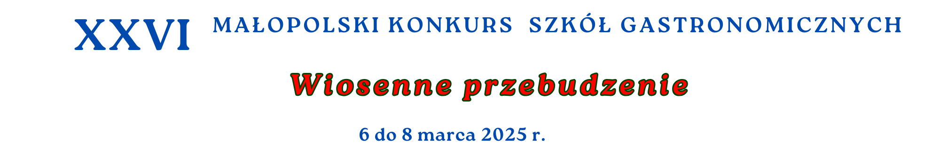

Portfolio na Konkurs Barmana 2025

Puree: Mandarine. Passionfruit, Pear, Jabuticaba, Pinneapple, Yuzu, Blueberry,
Pure:
Lemon Lime, Peach Apricot, Green Apple, Forest Fruit
Syropy:
Spiced Red Berries, Lemongrass, Bergamot, Elder Flower, Cucumber, Lavende, Wild Strawberry,
Mirabelle, Spicy Mango, Pink Grapefruit, Cloudy Lemonade Base, Muscovado,.Mojito, Orange spritz, Macaroon, Popcorn, Basil, Morello Cherry,
Mango, Blackberry, Lavende,
Koncentratt:
White Tea, Rantcho Lemon,
Bitter.
Soki Tymbark
Ananas, Banan, Czarna Porzeczka Nektar, Jabłko, Pomarańcza

